Towson High School
“Student Parking”
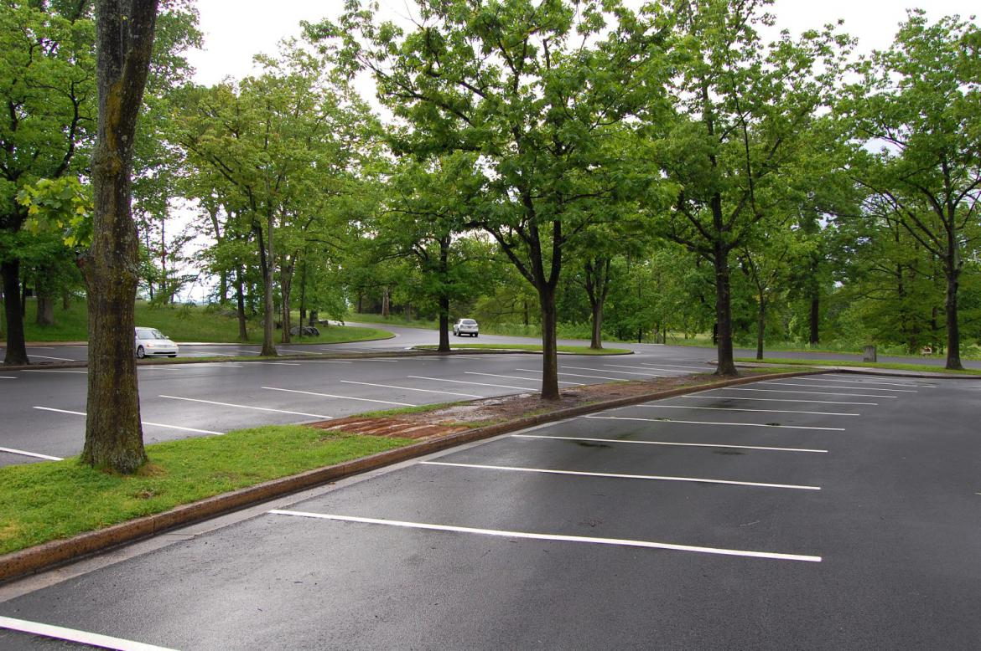
Welcome to school year 2021 -2022!

Towson High School is a neighborhood school surrounded on all sides by private residences and county streets. Over the years, we have outgrown our space and, consequently, have very limited parking. Students are eligible for access to student parking this year if they have a license, a vehicle, and a permit. We will issue permits based on a completed application only.

Having a ‘Student Parking Permit,’ however, does not guarantee a parking space. Students will only be able to park at school if they arrive early enough to gain a parking spot in the student lot. If they cannot find a space, they will have to park on the street where legal and walk. No student may park in any other lot on campus. As it is, our staff lots can't accommodate our staff, which includes teachers, paraeducators, adult assistants, counselors, administrators, cafeteria workers, custodians, and secretaries. We also have a large number of daily visitors, which includes parents, substitute teachers, student interns, central office personnel, and grounds, maintenance, and contract workers. They all have to park as well and will not be excluded from any staff or student parking spaces.

If you are interested in driving to school this year, please note the following.
- All student drivers must have a school issued ‘Student Parking Permit.’
- Student drivers must apply for a permit using the link below.
- Students must be logged into their BCPS Google Account to access this application.
- Permits will be issued within the first two weeks of school.
- Student drivers must park in the student lot only which is located
off Aigburth Avenue between the tennis courts and the softball field.
- When student drivers arrive to school in the morning, they may not stay in the lot or their
vehicles. Please report to the auditorium until the first bell unless needing breakfast in
the cafeteria.

Please copy and paste the address below into your Google Chrome browser.
https://docs.google.com/forms/d/e/1FAIpQLSfBUZz8XUFAs8RlX9r3RIHa-QtkxrovmRyI7OWB7O3N4cTRGA/viewform?usp=sf_link

